THE CHANGING SHAPES OF RED LADDER
The Agitprop Street Players – as Red Ladder was originally known – emerged when a group from a socialist information service performed a play at the Trafalgar Square Festival of 1968.
The plays were short and biting, morale-boosting sketches often relying on striking visual images to get the message across, they were highly portable relying on few props and were performed at mass political demonstrations, tenants association meetings, weekend schools etc.
Gradually the basis of the work broadened and plays that fed directly into particular struggles and issues developed; such as „The Big Con‟ against the Industrial Relations Act and „The Cake Play„against productivity bargaining,
The 60‟s were an era of riots, demonstrations and revolt – economic prosperity served to broaden political debate and theatre wanted to take part in this revolution of ideas. As it was conventional theatre changed little so the „alternative‟ emerged in the shape of fringe theatre. Red Ladder became a prominent member of the fringe movement, known as one of the best established political theatre companies in Britain.
By 1971, the name Red Ladder evolved, after a much loved and used prop. There also evolved a policy of taking theatre to „working class‟ audiences in places where working people usually find their entertainment, this now included trade union clubs.
By 1973 the commitment of the company was recognised with an Arts Council grant of £4,000 and in 1976 the company moved from London to Leeds, Yorkshire and is still based in the city, although it continues to tour on a national basis.
While early Red Ladder plays 1968-73 fed directly into political disputes of the time, below is a list of full length plays produced from 1974 together with changes in Artistic Policy.
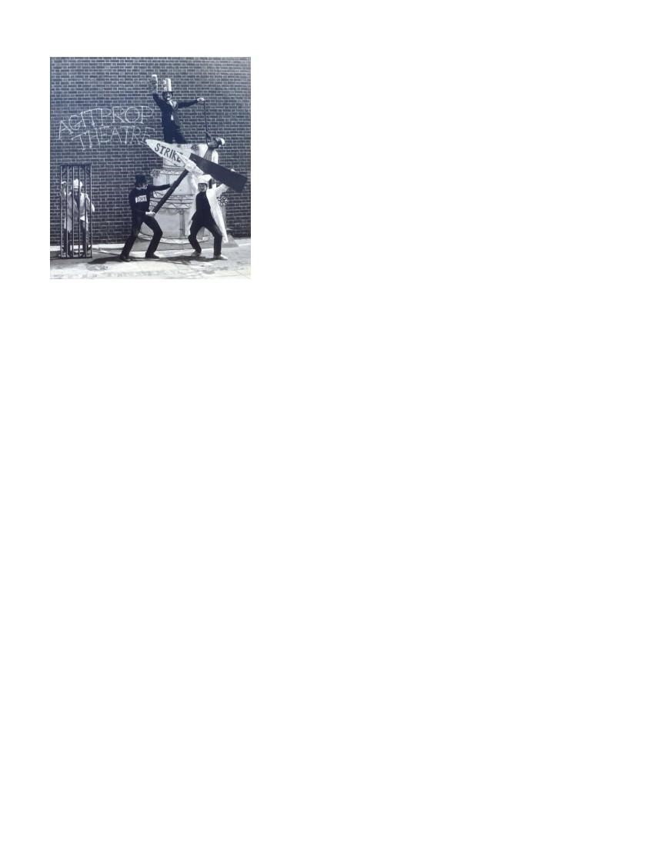
„Taking our Time‟, was a watershed in Red Ladders Artistic development: creating a more analytical approach to story telling as opposed to the simple solutions of Agitprop. The early 1980‟s became another watershed as it made the company consider the role and practice of political theatre in 1980‟s, a very different environment to that of the sixties & seventies. It led to a year of experimentation with new ideas, building on the experience of the past.
1985/86 led to another changing shape for the company from a Collective to a Hierarchy with the appointment of a Board of Directors who in turn employed an Artistic Director – Rachel Feldberg. Therefore the company developed a New Policy.
The Company’s aims were as follows:
- To create an artistically exciting socialist feminist theatre.
- To take this work to audiences who would not normally see theatre, young people 14 - 25 and the adults who work with them. To perform on their own ground, in Youth Clubs and places where they normally meet, rather than in theatre venues.
- To make our work accessible to all young people and in particular to reach young people for whom there is little or inadequate provision; young disabled people, Black young people (within which we include Asian and African Caribbean teenagers), young people in inner cities and isolated rural areas.
- To offer theatre of the highest possible standard which is exciting and challenging both for the audience and performers, which uses a wide variety of forms and which seeks to develop the vocabulary of this form of theatre by offering young people „the best‟.
- To base this work on issues of concern to our audience and to develop the ways in which theatre can be used which parallel groups and professions (for instance Youth Workers). To encourage these workers to use theatre as part of their work with associated training, preparation and follow up.
- To continue to implement and develop the Company‟s Equal Opportunities Policy (including our Anti-Racist strategy and Action Plan on Disability) placing it at the core of our work and seeking to achieve a fully integrated Company at all levels.
- To raise the profile of this area of work amongst other Companies, funding bodies and professional workers and to encourage Regional Arts Boards and Local Authorities/Youth Services to work in partnership.
The Artistic and Audience Developments were as follows:
- An innovative tri-part programme for Asian girls to include parallel projects in India and the North of England, coupled with development of a new, long term, Asian women‟s theatre project based in the North.
- A consistent development of the Company‟s work for disabled teenagers through a series of experimental projects - using sign theatre, dance and an environmental installation.
- A continued development of the Company‟s work with disabled performers, pursuing adequate funding for their support.
- A continued exploration of work with teenagers in unusual and artistically challenging environments, through a promenade piece and a mobile performance space for isolated rural areas.
- An emphasis on work which draws on different artistic and cultural forms. „Bilingual‟ work will be a focus of the three small scale „Work In Progress‟ projects.
- An extension of the Company‟s role encouraging new writing from under represented groups through the creation of an annual „Work In Progress‟ slot backed by dramaturge attachment.
In 1994 there was the Appointment of Kully Thiarai as Artistic Director.
New Mission Statement
Red Ladder is a national Touring Company, recognising that investment in young people is an investment in the future and is dedicated to:
- Creating and providing artistically exciting high quality theatre for young people who have little or no access to, or experience of the theatre;
- Touring new work nationally which, through exploring issues specifically designed for young people, is pure theatre;
- Developing strategies which offer young people the opportunity to become involved in the artistic life of this country;
- Striving for artistic excellence in its performance and presentation in a way which is accessible and challenging to its audience;
- Developing new writing and other theatre skills.
Again in1998 there was the Appointment of Wendy Harris as Artistic Director. As well as our professional touring productions 2002 saw the appointment of Madani Younis as director of the Asian Theatre School. Under Madani‟s direction the school created.
2004 Mission Statement:
To inspire and challenge the lives of young people. Red Ladder Theatre Company is:
- A high quality theatre experience for young audiences.
- National tours
- New work
- After show work
- The Asian Theatre School
2004 Artistic Policy: • To create theatre of the highest quality.
- To tour this work nationally targeting young people who have little or no access to theatre.
- To continue the artistic growth of the Asian Theatre School.To take artistic risks and explore new ways of working.
- To create excellent resource material and provide after show work. • To work collaboratively with artists to create new work
- To run To be informed by the young people and audiences we aim to reach.development weeks and creative labs for artists to experiment.
- To embrace new technologies, high quality production standards and highly skilled creative teams to offer • a unique artistic experience in non-theatre spaces as well as in theatres. • To offer an alternative view of the world through theatre.
•
Recognised as the UK‟s leading new writing company for youth audiences producing accessible theatre of the highest quality.
Red Ladder also provides:
- After show Chat backs
- Resource material for young people
2006 saw the Appointment of Rod Dixon as Artistic Director, and Madani Younis won the South Bank Award for Diversity.
Mission statement:
To make theatre which celebrates, inspires and challenges young people, developing in them the desire and ability to express ideas and strengthen social and cultural cohesion.
Artistic Policy To: • include young people in the creative processes of making theatre
- embellish current text-driven practice by experimentation with new theatre practice – including working with other art forms
- inspire a new generation of theatre makers through the quality and originality of our creative practice • tour this work nationally, targeting young people who have little or no access to theatre

•

•

•

•

seek international collaboration actively and to engage with theatre making in troubled parts of the

world
–

helping ordinary people investigate global issues

create a reputation for a unique Red
Ladder artistic process and a 21
st
Century style
–

to compliment

the reputation that precedes us.

continue to raise our local and regional profile particularly through enabling and inspiring emerging local

artists

celebrate and build upon Red Ladder
‟
s 40 y
ear history of making theatre.

Red Ladder Theatre Company is:

•

•

•

•

A high quality theatre experience for young audiences.

National tours and after show “Chat Backs
‟
.

Red Grit Actor Training Project

Customised Participatory Workshops

In 2007 The Asian
Theatre School moved to Bradford to become its own independent organisation, and was

rebranded as Freedom Studios.

1970
’s Production List

1974
-
75

A Woman
‟
s Work Is Never Done (also known as Strike While the Iron is hot)

Published by The Journeyman Press

Ab
out the role of women at work and home and their growing political awareness.

1975
-
76

It makes You Sick
by Frances McNeill

A club show about the N.H.S.; devised and written in close collaboration with N.U.P.E.

1976

–
77

Anybody Sweating
by Steve Trafford

A
club show about unemployment, high
-
rise flats, and Britain in 1976. It became known as „Would Jubileev It
‟
,

Red Ladder
‟
s contribution to the celebrations in 1977.

1978

Taking Our Time
by Steve Trafford & Glen Parkes

Published by Pluto Press

A play with mus
ic about industrialisation of the weaving industry in Yorkshire and the rise of Chartism.

Massively successful, it attracted a wide popular audience throughout Yorkshire and the North; supported by

the union of Dyers & Bleachers.

1979
-

80

Nerves of Steel
by Steve Trafford & Chris Rawlence

Explored the impact of the demands of working in the steel industry and the impact, overtime and shift working

had on family life.

Power Mad
by Steve Trafford

A reworking of the Faust legend around the subject of nuclear
power and arms.


1980
’s Production List

1980

Ladders to the Moon

An account of a strike in 1893 at Featherstone Pit in Yorkshire which resulted in the army shooting and killing

several miners.

1981

Circus
by Rony Robinson

An allegory in
which the state of Britain in 1981 was likened to an ailing circus of the 1930
‟
s, where the owner

deceives the workers who have no real control over their work.

The Blind Goddess
by Ernst Toller

The first extant script the company produced.

About socialism

in a fascist state, the position of women and the hypocrisy of justice. Translated for Red

Ladder by Micheline Wandor.

1982

Playing Apart

A club show about the effects of unemployment on a northern family. It countered the label of „scrounger
‟

usually lev
elled at unemployed people of the time. One of the first shows to use a rock band in the play, an

area which was rapidly developing within the company.

The Best of British „whose country is it anyway?
‟

A club show about life in post war Britain, from the „
never had it so good
‟

fifties, through the „swinging sixties
‟

and the „cynical
‟

seventies.

1983
-
84

Preparations
by Paul Goetzee directed by Rob Bettinson

The company’s first writing commission from Northern playwright Paul Goetzee.

In a dual storyline the
piece looked at a local council Civil Defence committee as they discuss plans for the

nuclear armageddon (comedy/satire) and in the other a teenage girl is admitted to a psychiatric clinic suffering

from a morbid fear of nuclear annihilation
(
psychological). The two overlap in a major geopolitical concern that

was current in the early 1980s.

Bring out your Dead
by Peter Cox

A club show looking at Britain
‟
s in 1988, after another term of Tory Government. Big Mac from America was

running the pri
vatised health service. The show did not achieve much success.

Dumb Blonde
by Peta Masters & Geraldine Griffins

Put together at very short notice following Bring out your Dead cancellations, this was a Busby Berkely style

musical written by Masters & Griff
iths with music by McGovan/Dougall, which took a light hearted look at

women at work.

1984

Happy Jack
by John Godber (an extant script)

The play charted the history of a coal miner and his wife through six decades of living on a pauper‟s wage.

The Beano by Rony Robinson A writing commission from South Yorkshire writer Rony Robinson
A hilarious yet sensitive account of a brewery worker‟s day trip to Scarborough in 1914. The revellers frolicked on their one day out, meanwhile the clouds of war were gathering in Europe.

This Story of Yours by John Hopkins
A new path for the company as it was aimed exclusively at Theatre venues.
A policeman is accused of murdering a suspected child abuser during an interrogation. The play explored male violence & sexuality from a highly charged position.

The Danderhall Red Beano
Not a show at all, but a week long festival mounted by red ladder in conjunction with Mid Lothian District Council in the mining village of Danderhall, near Edinburgh. A return to the true spirit and ethos of the Edinburgh fringe.
1985

Stitchin‟ the Blues & Mixing it by Maggie Lane
A double Bill. „Stitchin the Blues‟ was a one women show based on the Lee jeans occupation of 1981. „Mixing it‟ looked at what happened when an unemployed CND activist gets a job building a nuclear power station.

Safe with Us by Frances McNeill
A play commissioned by the Confederation of Health Service Employees Union for their 75_{th} Anniversary celebrations. A fast moving play which looked at current issues within the Health service, using comedy & music.

State Agent by Rachel Feldberg & Ruth Mackenzie
A new play for youth clubs about young people and homelessness, exploring what happened to young people who lost their benefit in the now forgotten ( but then notorious) „ bed & breakfast‟ laws. 1986

Back to the Walls by Jane Thornton
A new play based on young people’s experience of Youth Training Schemes.
Targeting young people 15+, unemployed people & school leavers.
On the Line (devised) Beat Box Britain. A country where “there is no such thing as a racist attack”. On the Line looks at the origins of racism – where does it come from, who profits and most important, what are we going to do about it? Written for youth clubs, tackling a difficult issue in a lively and accessible way.

Spring 1987

Winners
by Rona Munro

Specially written for young women exploring gender issues.

Autumn 1987

Empire Made
by Paul Swift

Play for senior youth groups about Racism
and police attitudes.

Winter 1988

One of Us

By Jacqui Shapiro & Meera Syal

A comedy about Nishi
‟
s life as she grapples with her expectations & the realities of the world around her.

(
Targeting Asian Girls Groups
)

Spring 1988

Off the Road
by Rona Munro

A
show comparing rural and city life touring to girls groups.

Autumn 1988

The Best
by Mike Kenny

A play exploring deaf issues for young deaf people.

Spring 1989

Bhangra Girls
by Nandita Ghose

The first commissioned work touring to young Asian girls groups.

A
utumn 1989

Who's Breaking
by Philip Osment

Play for mixed senior youth clubs focussing on HIV/Aids issues, integrating
British Sign Language.

1990
’s Production List

Spring 1990

Bus Shelter Project
by Lin Coghlan

Tour for young people meeting on the street
concentrating on homelessness & poverty.

Autumn 1990

Breaking the Silence
by Kate O’Reilly

Specially written for disabled, Asian and Girls groups, integrating British.Sign.Language

Spring 1991
The Scrappie by Judith Johnson
Play about loss and separation for mixed senior youth clubs.
Autumn 1991
Consequences by Mary Cooper
Play touring to Asian girls groups.
Winter 1992
Listen by Philip Osment
Play about a deaf young person and family relationships, using B.S.L

Spring 1992
Though the Heavens Fall by Lin Coghlan
Play about justice and law for senior youth club audiences.
Autumn 1992
Caught by Julie Wilkinson
Play for girls groups focussing on teenage pregnancy, integrating B.S.L.

Spring 1993
No Mean Street by Paul Boakye
A joint project between Kuffdem Theatre Co. & Red Ladder exploring HIV/Aids targeting Black young people.
Autumn 1993
Sleeping Dogs by Philip Osment
Play for mixed senior youth clubs focussing on intercommunal strife in Eastern Europe.

Spring 1994
Mixed Blessings by Mary Cooper
Play for girls examining mixed race relationships between African Caribbean & white young people.
Autumn 1994

The Wound by Gilly Fraser
Focussing on domestic violence, touring senior mixed youth clubs.

Sleeping Dogs
By Philip Osment
Retour to Arts Centres and small scale theatre venues.
Spring 1995
Waking by Lin Coghlan
Set in Ireland, a play touring to mixed senior youth exploring clubs issues of cultural identity, family and loss.

Spring 1996
End of Season by Noel Greig

1_{st} International Co- Production with Red Ladder & Theatre Direct, Canada
A play touring to youth club audiences and theatre audiences exploring tribalism youth violence and cultural identity.
Autumn 1996
Josie's Boys by Roy Williams
A play touring to youth club audiences about single parenting, leaving home and ambition.
Spring 1997

Kaahini by Maya Chowdhry
A play touring to youth club and theatre audiences for Asian young people 14+ about gender, duty and kismet.
Autumn 1997
Crush by Rosy Fordham
A comedy about infatuation, fantasy and reality, men and women, and Boy bands!
Spring 1998
Wise Guys by Philip Osment
A co-production with Theatre Centre, exploring male identity and violence.
Autumn 1998

Crush by Rosy Fordham
A national retour to Arts Centre & Youth Service.

Autumn 1999

Last Night
by John Binnie

Story of a pregnant teenager, an old man & refugee. Set on New years eve of 1999.

2000+
Production List

Spring 2000

After the End of the World
by Mike Kenny

Red Ladder's
Millennium Play, a comedy exploring respect and morality with Stick, a teenage boy living with

Chintz, his single parent Mum and Wrinkle, his disabled Grandma.

Autumn 2000

Picture Me
by Noel Greig

An international story set in England & Mumbai exploring
the emotional impact of HIV/Aids on British Asian

teenager.

Spring 2001

Hold Ya
by Chris OConnell

Story of single parent Dad & his teenage son, a gritty story about love & change mixing club land culture &

domestic life.

Autumn 2001

Lowdown Highnotes
by An
drea Earl

Story of a „teenage wannabe
‟

which takes her off to find her real father, using music, video imagery and live

vocals.

Spring 2002

After You
by Brendan Murray

A story about a youth who searches for the truth with evocative text, video imagery,
movement and design,

beautifully crafted in this gripping piece of theatre. A chance meeting with a stranger at his dad
‟
s graveside

sets Chris off on a trail of intrigue and discovery. But Chris uncovers more than he bargained for, forcing him to

re
-
evalua
te his relationship with his parents. Cutting edge digital media, design & evocative text is beautifully

crafted in this gripping piece of theatre.

Autumn 2002

Wise Guys
by Philip Osment

Re
–
Tour Directed by Wendy Harris

Wise Guys bursts into action with
the passion and drama of street culture combined with dynamic Teenage

energy. Uproariously funny and deeply moving the play follows the journey of a gang of urban youth, mixing

cutting edge digital media with a strong physical theatre style.

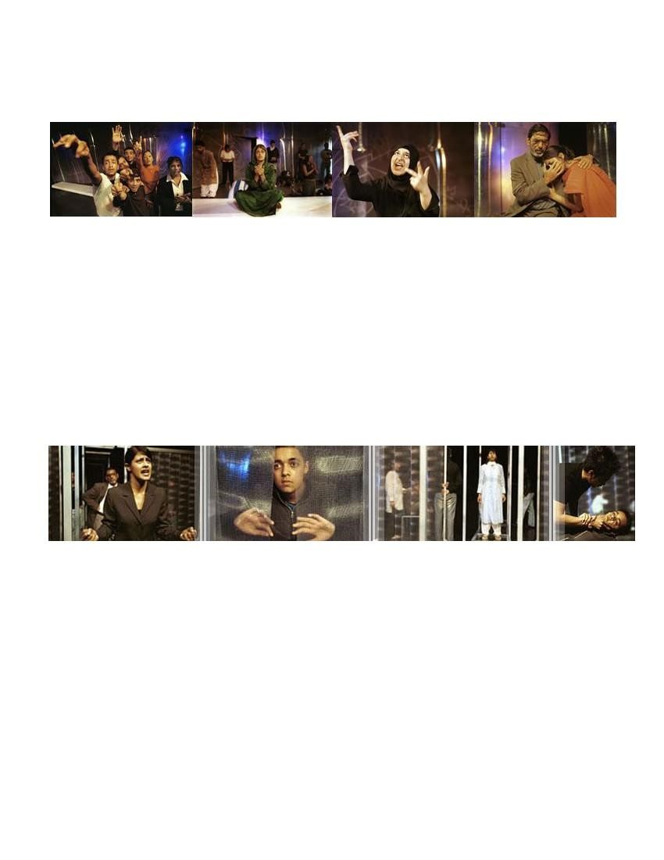
Spring 2002

STREETS OF RAGE:
A CREATIVE RESPONSE FROM THE YOUNG PEOPLE OF BRADFORD

Directed by Madani Younis & Sarah Brigham

Performed by the Asian Theatre School

Streets of Rage
opened eyes to the events of the Bradford riots of last summer. Mixing cut
ting edge digital

media, the play gave a new voice to a group of young men and women from Bradford , heard on stage for the

first time.

Devised by the Asian Theatre School participants, in response to the views of local people of Bradford the

opportunity
to re
-
tell the events of the riots from their perspective.

This well researched and innovative piece of theatre is the result of news footage analysis and interviews with

members of the public who lived through the riots, and who are still dealing with the

issues that were brought to

life.

2003

Silent Cry

Directed by Madani Younis & Sarah Brigham

Performed by the Asian Theatre School

Silent Cry…

A family looking for justice.

We hear the voices of an ordinary family who once had an ordinary life.

A death in
Police custody.

We see a Mother
‟
s journey that begins as her son
‟
s life ends.

A system with no answers.

We tell a story based on true documented evidence and interviews.

Following the unprecedented success of STREETS OF RAGE the Asian Theatre School brings

untold stories

from the hearts of communities to the stage. ATS has its finger on the pulse of a multi
-
cultural modern Britain.

The show performed to full houses at Bradford Alhambra Studio & the West Yorkshire Playhouse.

“It is educational, painful, and
a pleasure.” Bradford Telegraph and Argus

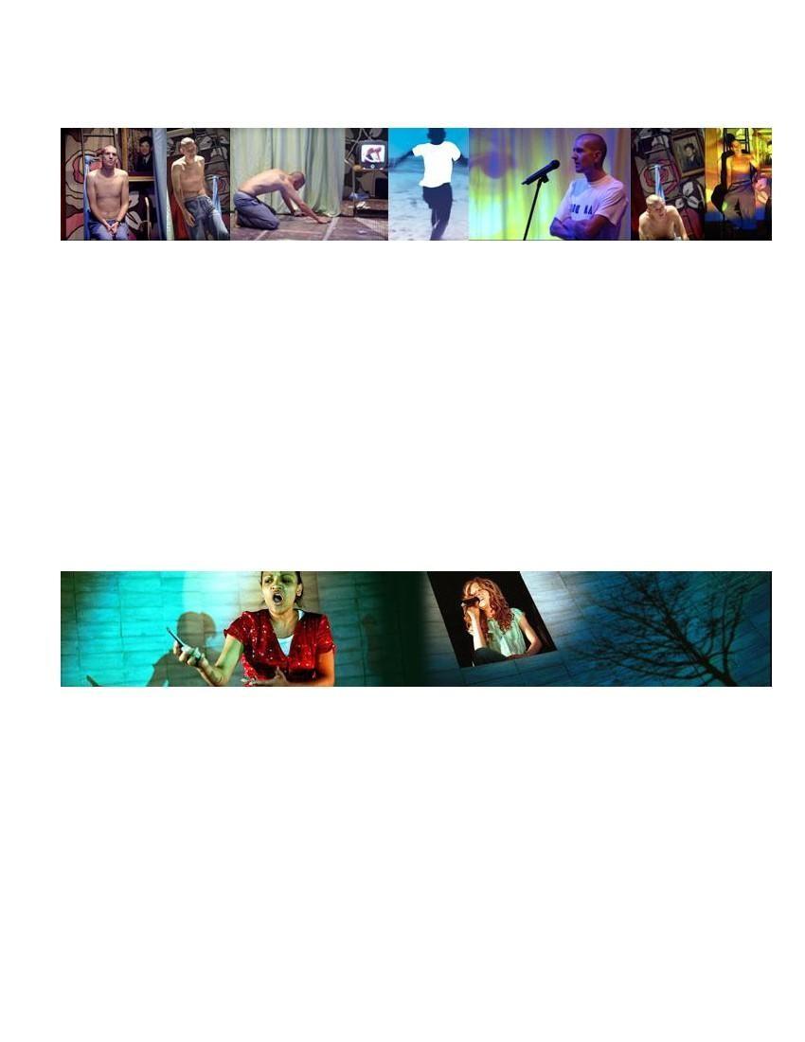
2003

The Dreaming of “Bones”
by Damian Gorman

Red Ladder & Contact Theatre , Manchester Co production

Directed by Shabina Aslam

The heart
-
hitting story of a heart
-
scalded young man.

Xavier „Bones
‟

MacMillan, like many young people, dreams of a special, beautiful life for himself.

In preparation for a stay at the local “Thin Bin” he rehearses the story of his past and present life: his „over
-

worrying
‟

mum, his estranged dad, his cool mate Lenny and his dream girl, Nicola Price all play their part.

Weaving dramatic monologue, poetry, movement and original music “The Dreaming of Bones” looks at how

the strong, true yearning of one young person can overco
me the often warped, harsh realities of life pressing in

around him.

Damian Gorman is one of the most socially significant contemporary Northern Irish writers working in both film

& theatre. He has won numerous awards, including 4 Peacock Ulster Theatre aw
ards Northern Ireland
‟
s first

BAFTA and an MBE for his service to the arts.

2004
Tour April
–

July

Soulskin
by Esther Wilson

Directed by Wendy Harris

A story about fractured families, loyalty, destructive pride, and taking responsibility. Suitable for 13+

Chrissie, the child of a teenage pregnancy, has been brought up by her Gran, Mary. She
‟
s hasn
‟
t seen her

Mum, Bernie, in years until Mary dies. It
‟
s the night of the funeral and the eve of Chrissie
‟
s sixteenth birthday.

She
‟
s alone in the house, waiting fo
r Bernie (Mum) to pick her up. As she packs Chrissie tries to make sense

of the painful memories and secrets that have kept the family apart. But as the sun sets, Chrissie
‟
s memory

plays tricks, conjuring up strange meetings, with real and imagined situati
ons haunting her until…. Mary herself

appears and Chrissie has to face up to her part in the fragile relationship between mothers & daughters.

Walking into the future is hard. This is about finding the courage to do it amid a blur of Fantasy, memory and

re
ality. A brilliant new work with an original sound track and evocative film imagery

“Superb….hard hitting and attention grabbing
–

not only a splendid piece of theatre, but a powerful tool for

influencing lives.” Reviewgate.com

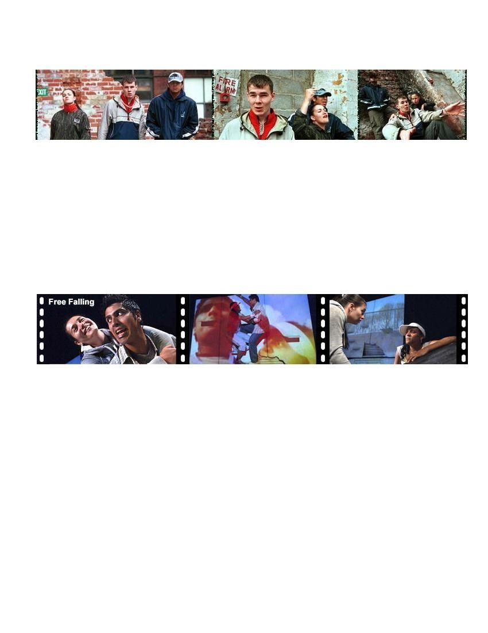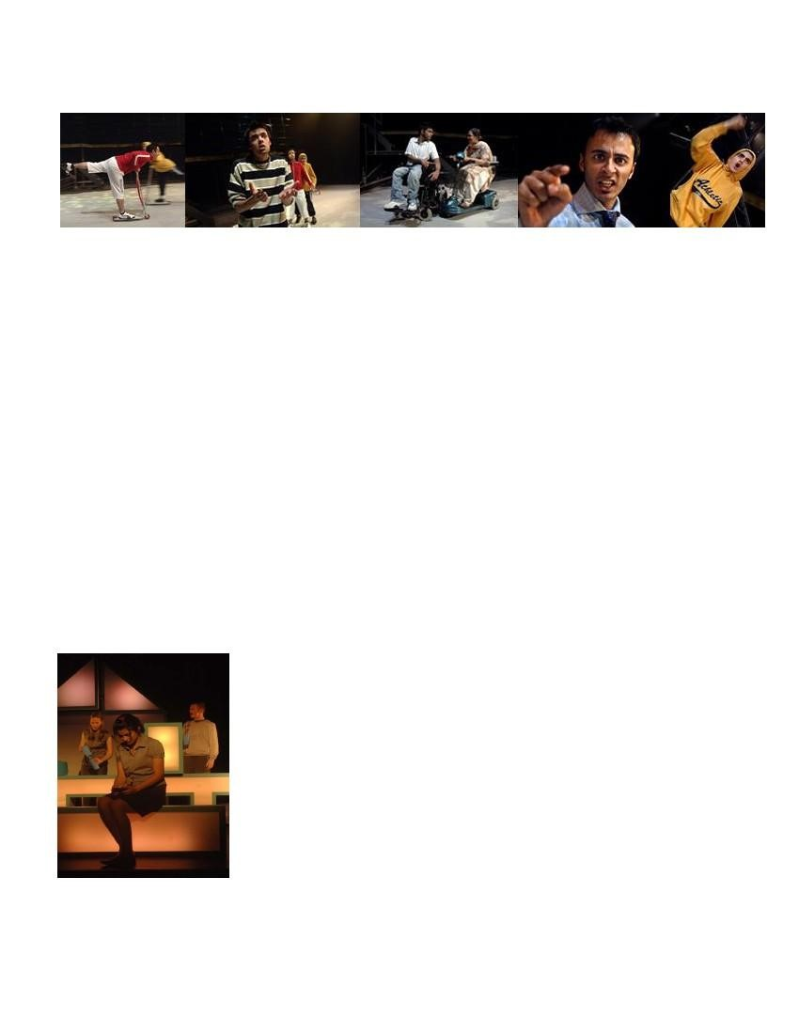
2004
Tour
Sept
–

Dec

Tagged
by Louise Wallwein

Directed by Faroque Khan

Developed in collaboration with Half Moon Young People's Theatre, London

Time is ticking by for Chris. He
‟
s electronically tagged and on a 7o
‟
clock curfew. If he breaks it he
‟
s going

down. Two
friends, a bike, a pylon, a tractor and a police helicopter conspire to keep Chris from his freedom.

Exclusion and frustration rule this molotov cocktail of poetry, quick fire dialogue and urban sound
-
and
-
visions

capes. The young audience entered the theat
re chatting during the opening scenes; by five ,minutes into the

narrative they were gripped. This wonderful new play about society's desire to tag anything that moves is a real

eye
-
opener.

-

Glenn Meads (reviewed at Manchester’s Contact Theatre)

2005
Tour

April
–

July

Free Falling
by Madani Younis

Directed by Wendy Harris

Roof tops a jumping,

Kites flying as high as,

A school that’s failing

Gang o’ youth waiting,

Hot summer burning,

A generation that’s free falling…

A new play developed with young people
in Yorkshire and a team of artists from Red Ladder
-

inspired by the

urban sport of Free running (or le Parkour) with strong visual imagery and storytelling that will connect with

youth across Britain. Suitable for anyone over 13 years. This play contains
strong language.

Free Falling
-

a play about success and failure, about a search for beauty about a generation of youth looking

for a future. Multi media, hip beats, cool moves and inspirational words challenge young audiences creating

visionary theatre th
at impacts and reflects the diversity of our society.

2005
Autumn Production

Caravan

Written & directed by Madani Younis

Performed by Asian Theatre School

At the end of a run down street with back to back houses that frown at one another
and whose gardens have seen

better days, the Caravan sits patiently and quietly.

Caravan looks at the lives of ordinary people and how communities endeavour to continue a normal existence in

the face of terror, media hype and a global society at odds with
itself. The production is inspired by Caravaggio
‟
s

The Seven Works of Mercy

This new piece of theatre is performed by the Asian Theatre School, whose unique brand of theatre brings stories

from the hearts of the cities and communities of multi
-
cultural mod
ern Britain to the stage.

Pay it Forward

A unique series of artistic partnerships between various performance groups across the region with support from

Stage Exchange. A Pay It Forward performance preceded each performance of Caravan.

Proper Job & Suga Br
own Thurs 1
st
Sept,

DAZL & Vera Media performing Fri 2
nd
Sept

RJC & Leeds Young Authors Sat 3
rd
Sept

2006
Tour May
–

July

Worlds Apart
by Mick Martin

Directed by Juliet Ellis

Worlds Apart takes us into the of life of Sam Harris, a 14 year old girl dealing
with

life, love, communication and difference in the world around her. At home there
‟
s

Mum, her step dad Pete and her eight year old half brother Adam. Adam is

autistic. At school there
‟
s her best mate Kelly to whom she tells everything. Enter

Sam
‟
s world
and share her joys, her confusions and her frustrations as she gives

her thoughts and feelings about boys, parents and Adam.

Using multi
-
media, illustration, original sound and light design, Red Ladder

creates visionary theatre that reaches out to teenage
and adult audiences. During

the making of the play the company was inspired by PECS
-

The Picture

Exchange Communication System
-

a non verbal communication system that has

been successful with adolescents and adults who have a wide array of

communicative,

cognitive and physical difficulties. The play integrates this system

in a creative and stimulating way.

.

-

‟

to raise expectations of what theatre itself can do.

pretending to be film or television, aiming instead

We either change the way we live, or the world in which we live changes us forever.

century hell?
st
this 21
Can anyone escape

lies and deceit smother the truth.

–
Painful old wounds split open

Frederick arrives.

master; Jo hides behind his angry mask; Leah comforts herself in fantasy.
-
manipulates like a cruel puppet

struggles, the web tightens. Giles teases and

Written Madani Younis

